Flash 8
Flash-MX-完美演繹(知城)
P2_4.fla & P2_10.fla
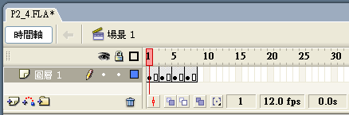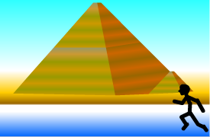
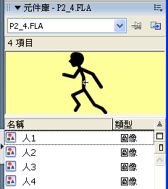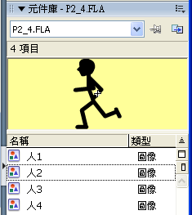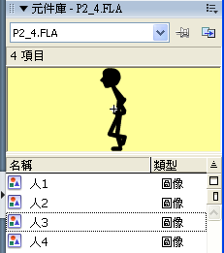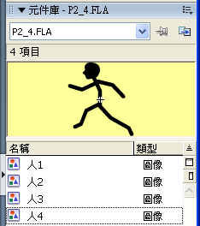
P2_5.fla
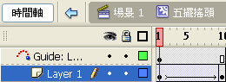
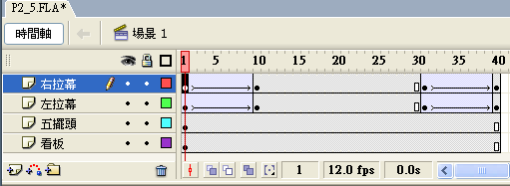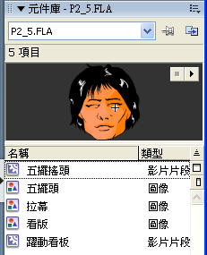
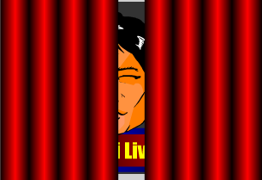 10  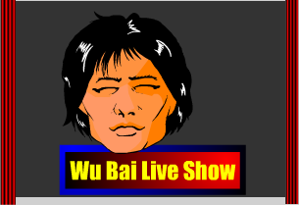
拉幕
看版
P2_6.fla
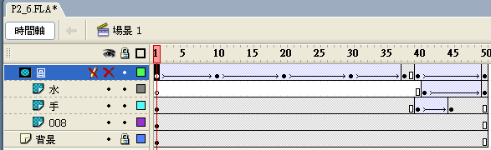 背景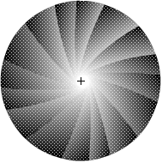
 40  41 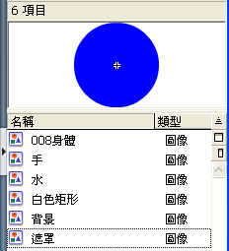
P2_7.fla
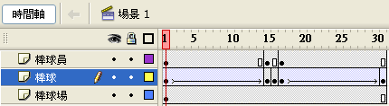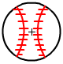
1 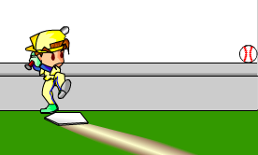 15 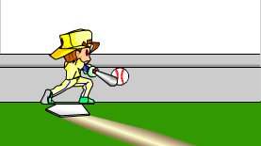 17 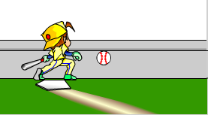

P2_8.fla
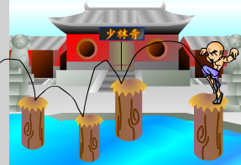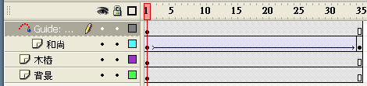
P2_11.fla
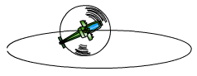
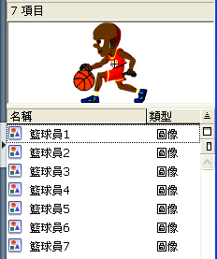 P2_11_3.fla 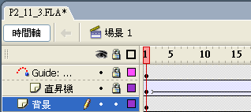 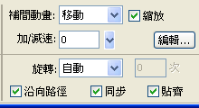

P3_2-x.fla

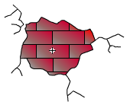
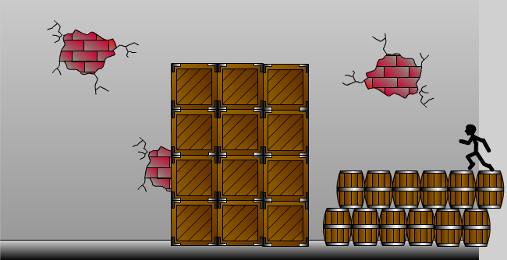木捅木箱
10
15
25
35
45
磚塊牆壁
旋轉
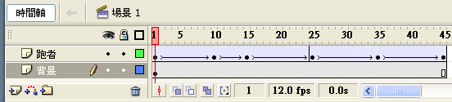
P3_3.fla
元件庫 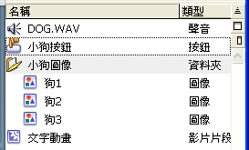 按下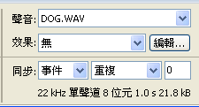

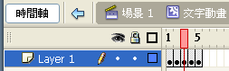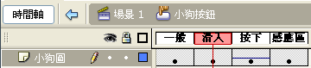
on (release) {
gotoAndPlay(1);
}

P3_5.fla
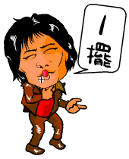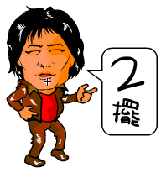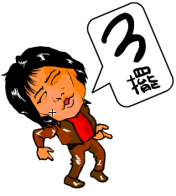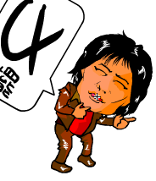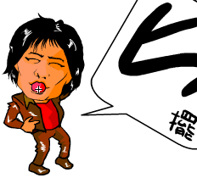
P3_6.fla


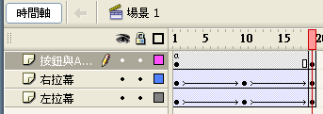 1-10開幕 11-20閉幕
Play_btn.onPress = function() {
play();
};
Stop_btn.onPress = function() {
stop();
};


P3_7.fla
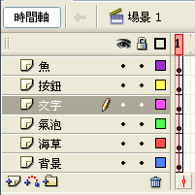
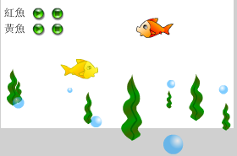 氣泡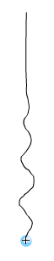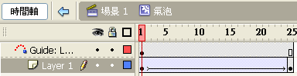 水草
on (release) {
_root.RedFish_mc.play();
}
RedFish_mc
YellowFish_mc
on (release) {
_root.RedFish_mc.stop();
}
P3_8_3.fla
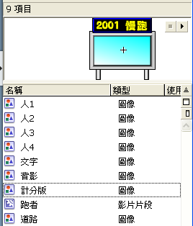
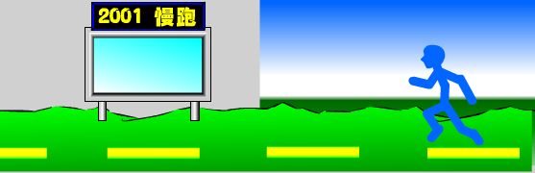
舞台
道路
計分板
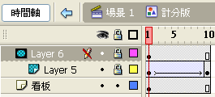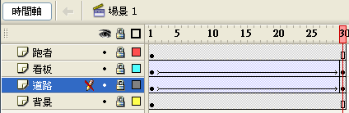
看板、道路 (由左至右移動)
P4_2.fla

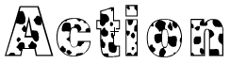

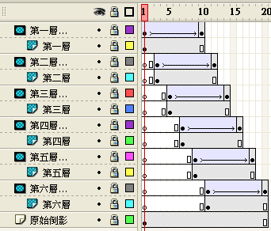
波紋下移
文字
文字倒影

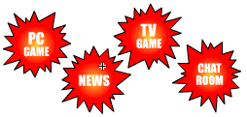
3
5
7
9
P4_3.fla
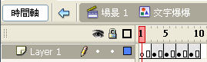


mask
火花
P4_4.fla
powerpoint effects
售票處
售票處
售票處
縮放

時間
飛入
2011-12-25
風車
桃園巨蛋
出現

P4_6.fla
onClipEvent (mouseMove) {
_root.noBtn._x = random(200);
_root.noBtn._y = random(350);
}
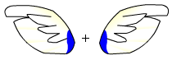
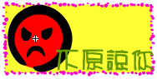
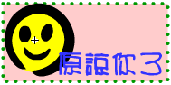
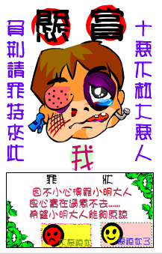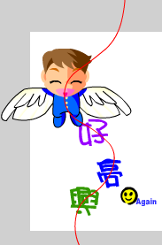
P4_5.fla 賀年
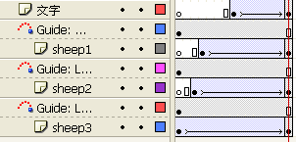


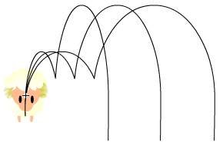
12個按鈕
三羊動畫
三羊四季花開五福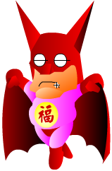雙猴財神
on (release) {
gotoAndStop(1);
}

P4_7_4.fla
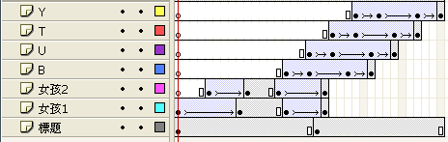

B
alpha=0%
B
alpha=30%
alpha=80%
alpha=40%
B
B

P4_7_6.fla
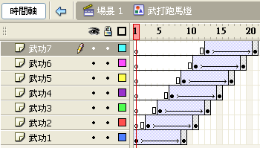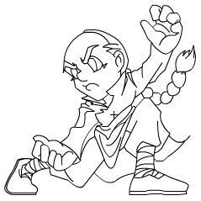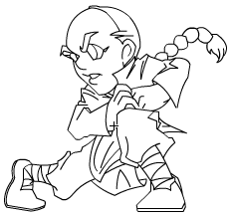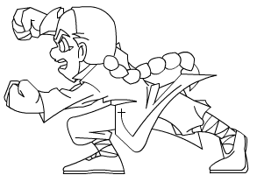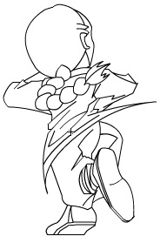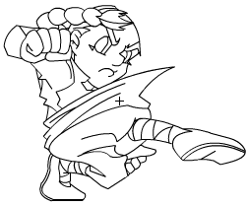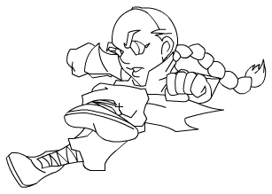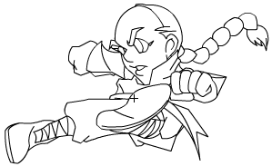
alpha = 100% → 0%

P4_7_7.fla
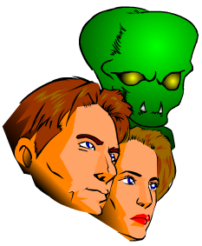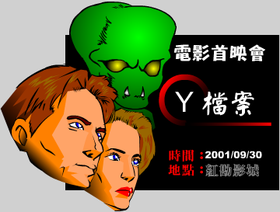

P4_7_8.fla
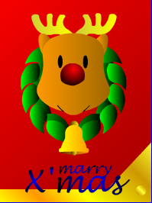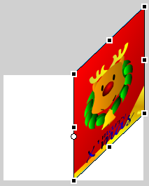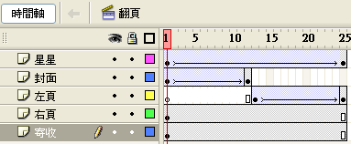
閃爍鼻子按鈕
P4_7_9.fla 你喜歡我嗎? 喜歡/不喜歡


P5_2.fla
on (release) {
getURL("http://www.kimo.com.tw", "_blank");
}
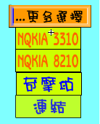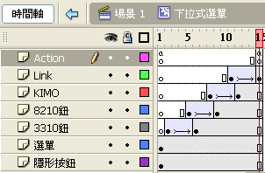
on (rollOver) {
gotoAndPlay(2);
}
on (rollOver) {
gotoAndStop(1);
}
P5_4.fla
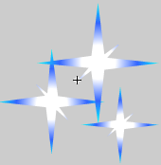星星影片 (縮小，消失)
Star_mc.onEnterFrame = function() {
Star_mc._x = _xmouse;
Star_mc._y = _ymouse;
i++;
if (i>8) i=1;
duplicateMovieClip(this, "Star_mc"+i, i);
Star_mc._visible = false;
}

P5_5.fla

mouse.hide();
startDrag("Man_mc", true);
stop(); //雪花
Hidden_btn.onRollOver = function() {
gotoAndPlay(2);
}
P5_6.fla
米老鼠影片 (alpha=100% → 0%)
mouse_mc.onEnterFrame = function() {
mouse_mc._x = _xmouse;
mouse_mc._y = _ymouse;
i++;
if (i>8) i=1;
duplicateMovieClip(this, "mouse_mc"+i, i);
mouse_mc._visible = false;
}

P6_2.fla
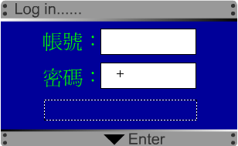
on (release, keyPress "<Enter>") {
num++;
Pass_mc.txtShow = "帳號或密碼答錯" + num + "次";
if (Pass_mc.txtId == "Flash MX" and Pass_mc.txtPass == 12345678) {
gotoAndStop("登入成功", 1);
} else {
if (num == 3) {
gotoAndStop("登入失敗", 1);
}
}
}
變數: txtId, txtPass, txtShow
P6_4.fla
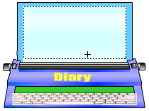
onClipEvent (load) {
loadVariables("news.txt", this);
this.stop();
}
onClipEvent (data) {
this.gotoAndPlay(2);
}

news.txt:
show=新學期!新希望!

P7_6.fla
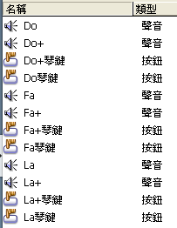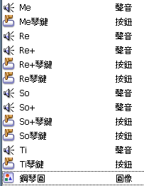按鈕按下→聲音

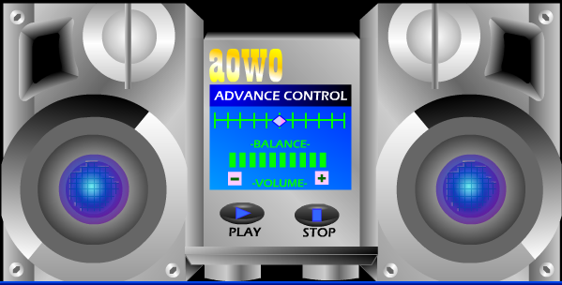
P7_6.fla (難)

P7_6.fla
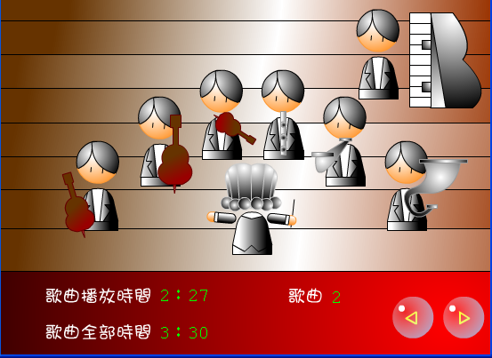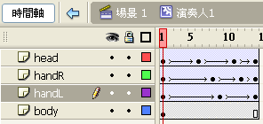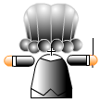
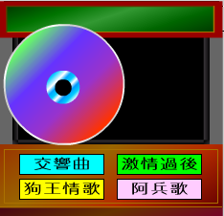
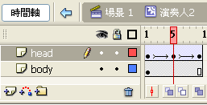元件：頭、手、樂器1-5、背景、演奏者1-2
P7_9.fla
sndD = new Sound();
sndA.attachSound("idA");
txtNum = 1;
GetMusic(txtNum);
function GetMusic(num) {
M_sound = new Sound();
M_sound.stop();
M_sound.loadSound("Music/M"+txtNum+".mp3", true);
}
P8_1.fla
_root.onEnterFrame = function() {
if (Circle_mc.hitTest(Rectangle_mc)) {
txtShow = "碰到了！";
Movie1_btn.onRelease = function() {
_root.Movie_mc.pos_y = 0;
};
Movie2_btn.onRelease = function() {
_root.Movie_mc.pos_y = -220;
};
Movie3_btn.onRelease = function() {
_root.Movie_mc.pos_y = -440;
};
Movie4_btn.onRelease = function() {
_root.Movie_mc.pos_y = -660;
};
Movie_mc.onLoad = function() {
this._y = 0;
this._x = 0;
};
Movie_mc.onEnterFrame = function() {
old_y = this._y;
diff = this.pos_y-old_y;
move = diff/5;
this._y = old_y+move;
};
} else {
txtShow = "沒碰到！";
}
}
P8_2.fla
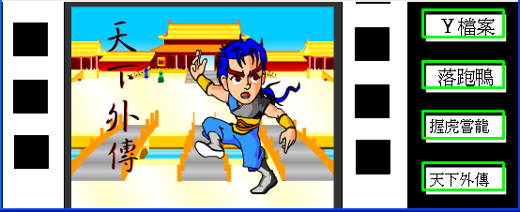

P8_2.fla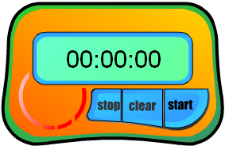 P8_3.fla 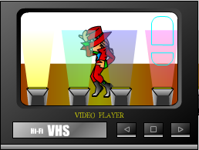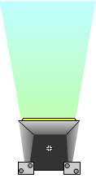探照燈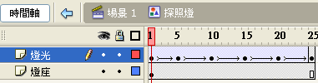排燈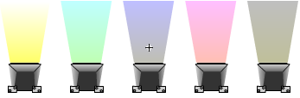

P8_4.fla
海浪影片  內嵌視訊

P8_6.fla
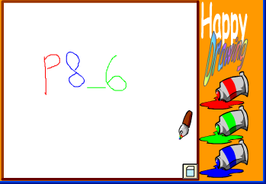 P8_7.fla 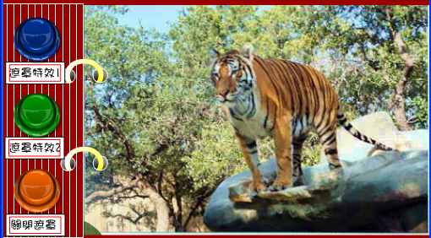
P9_2.fla 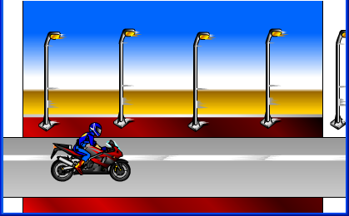 P9_3.fla 

