1 絕對值 (|x|)
FUNCTIONS函數 | RESULTS結果 | MEANING意義
=ABS(1–4) | 3 | absolute value
=ABS (–2) | #NAME? | no blank
2 整數
=INT(18/5), =INT(3.65) | 3 | integer part
=INT(–4.3) | –5
3 去除小數
=TRUNC(3.65) | 3 | Truncate截尾
=TRUNC(–4.3) | –4
=TRUNC(123.456) | 123 | =INT(123.456)
=TRUNC(123.456,1) | 123.4 | 1位小數 (0.1)
=TRUNC(123.456,2) | 123.45 | 2位小數 (0.01)
=TRUNC(129.456,–1) | 120 | 十位

4 餘數 (a%b)
=MOD(19,4) | 3 | 餘數remainder of 19/4
=MOD(–15,4) | 1 | 意義不大
=MOD(15,–4) | –1
=MOD(–15,–4) | –3
5 四捨五入 ROUND, ROUNDUP, ROUNDDOWN
=ROUND(125.678,0) | 126 | 126 | 125 | 準確至1 (個位)
=ROUND(125.678,1) | 125.7 | 125.7 | 125.6 | 1位小數 (0.1)
=ROUND(125.678,2) | 125.68 | 125.68 | 125.67 | 2位小數 (0.01)
=ROUND(125.678,–1) | 130 | 130 | 120 | 十位 10
=ROUND(125.678,–2) | 100 | 200 | 100 | 百位 100

6 平方根
=SQRT(16) | 4
=SQRT(–16) | #NUM! | Error
7 次方(xⁿ) ~pow()
=POWER(2,3) | 8 | =2³ 三次方
=POWER(3,2) | 9 | =3² 二次方
=POWER(2,–3) | 0.125 | =2‾³
8 隨機數
=RAND() | 0 ≤ x ≤ 0.999 | random number (0–0.999)
=RAND()*100 | 0 ≤ x ≤ 99.999
=INT(RAND()*100) | 0 – 99 | C: n=rand()%100;
=INT(RAND()*6)+1 | 1 – 6 | C: n=rand()%6+1;
9 平方和 (a²+b²)
=SUMSQ(3, 4) | 25 | =3²+4²
=SUMSQ(10) | 100 | =10²
=SUMSQ(A1:A3) | 14 | A1=1,A2=2,A3=3

 | A | B | C | D | E
1 | 3 | TRUE
2 | 5 | 10
10 總和 ∑
=SUM(A1,B1,2) | 5 | =3+TRUE(文字)+2
=SUM(A2:B2, 15) | 30 | =5+10+15
=SUM(3, 2) | 5
=SUM("3", 2, TRUE) | 6 | =3+2+TRUE(1)

 | A | B | C | D | E
1 | 7 | 10 | 4 |  | Sales
2 | 3.5 | 7 | 18 |  | 12/8/90
3 | 3.5 | 9 | 7
4 | 1 | 27 |  |  | 19
5 | 2 | 2 |  |  | 22.24
6 |  |  |  |  | TRUE
7 |  |  |  |  | #DIV/0!
11 排名次 =RANK(數值Num,範圍Ref,次序Order)
=RANK(A1, A1:A5, 0) | 1 | =0 由大至小descending
=RANK(A1, A1:A5) | 1 | 同上
=RANK(A1, A1:A5, 1) | 5 | ≠0 由小至大ascending
12 平均分
=AVERAGE(B1:B5) | 11 | =(10+7+9+27+2)/5
=AVERAGE(Scores) | 11 | Scores = B1:B5
=AVERAGE(B1:B5,5) | 10 | =(10+7+9+27+2+5)/6
13 數一數 (數字、日期)
=COUNT(E1:E7) | 3 | 數字儲存格
=COUNT(E1:E3) | 1 | 包括date
=COUNT(E1:E7, 2) | 4
14 數一數 (非空格，空格)
=COUNTA(E1:E7) | 6 | 非空白non–blank
=COUNTA(E1:E7, 2) | 7
=COUNTBLANK(E1:E7) | 1 | 空白blank cells

 | A | B | C | D | E
1 | apples | oranges | peaches | apples | =IF(C3<50,"",C3)
2 | 32 | 54 | 75 | 86 | =IF(C3<50,0,C3)
15 數一數 (範圍，條件)
=COUNTIF(A1:D1,"apples") | 2 | 如果等如"apples"
=COUNTIF(A2:D2,">=55") | 2 | 如果大於或等如55
=COUNTIF(A2:D2,">"&B2) | 2 | 如果大於54
16 如果．．，則．．，否則．．
=IF(A10>=50, "Pass", "Fail") | 如果A10>=50，則"Pass"，否則"Fail"
=IF(A10=100,SUM(B5:B15),"") | 如果A10=100，則SUM(B5:B15)，否則""
=IF(A2>89, "A", IF(A2>79, "B", IF(A2>69, "C", IF(A2>59, "D", "F"))))

 | A | B | C | D
1 | 房屋價值 | 銷售佣金 |  | 10
2 | 100,000 | 7,000 |  | 7
3 | 200,000 | 14,000 |  | 9
4 | 300,000 | 21,000 |  | 27
5 | 400,000 | 28,000 |  | 2
17 加總B2:B5，如果A2:A5大於160000
=SUMIF(A2:A5,">160000",B2:B5) | 63,000
18 最大、最小
=MAX(D1:D5) | 27 | 最大
=MAX(D1:D5,30) | 30
=MIN(D1:D5) | 2 | 最小
=MIN(D1:D5, 0) | 0

 | A | B | C | D
1 | Frequency | Color | 顏色
2 | 4.1423 | red | 紅
3 | 4.1934 | orange | 橙
4 | 5.1723 | yellow | 黃
5 | 5.7734 | green | 綠
6 | 6.3898 | blue | 藍 | 已排序
7 | 7.3134 | violet | 紫 | ** Sorted List
19 LOOKUP(目標數值，尋找範圍，回傳範圍) sorted list required
=LOOKUP(4.91, A2:A7, B2:B7) | orange
=LOOKUP(5.00, A2:A7, B2:B7) | orange
=LOOKUP(7.66, A2:A7, B2:B7) | violet
=LOOKUP(1.66, A2:A7, B2:B7) | #N/A
=LOOKUP(4.91, A2:A7, C2:C7) | 橙
=LOOKUP("RED", B2:B7, C2:C7) | 紅 | not case sensitive
=LOOKUP("blue", B2:B7, C2:C7) | #N/A | B2:B7 is unsorted
20
=LOOKUP("C",{"a","b","c","d";1,2,3,4}) | 3
=LOOKUP("bump",{"a",1;"b",2;"c",3}) | 2

 | A | B | C | D
1 | Axles | Bearings | Bolts | 汽車零件存貨
2 | 4 | 4 | 9
3 | 5 | 7 | 10
4 | 6 | 8 | 11
21 HLOOKUP(目標數值，尋找範圍，回傳範圍，近似)
=HLOOKUP("Axles", A1:C4,2,TRUE) | 4
=HLOOKUP("Bearings",A1:C4,3,FALSE) | 7
=HLOOKUP("Bearings",A1:C4,3,TRUE) | 7
=HLOOKUP("Bolts",A1:C4,4) | 11
=HLOOKUP("Bolt",A1:C4,4,TRUE) | 8

 | A | B | C | D
1 | 在1 atm壓力下的空氣
2 | 密度 | 黏度 | 溫度
3 | (kg/m³) | (kg/m*s)*10⁵ | (°C)
4 | 0.457 | 3.55 | 500
5 | 0.525 | 3.25 | 400
6 | 0.616 | 2.93 | 300
7 | 0.675 | 2.75 | 250
8 | 0.764 | 2.57 | 200
9 | 0.835 | 2.38 | 150
10 | 0.946 | 2.17 | 100
11 | 1.09 | 1.95 | 50
12 | 1.29 | 1.71 | 0

22 VLOOKUP(目標數值，尋找範圍，回傳範圍，近似) 設Range = A4:C12
=VLOOKUP(1,Range,1,TRUE) | 0.946 | 最接近=TRUE
=VLOOKUP(1,Range,2) | 2.17 | default = TRUE
=VLOOKUP(1,Range,3,TRUE) | 100
=VLOOKUP(.746,Range,3,FALSE) | 200
=VLOOKUP(0.1,Range,2,TRUE) | #N/A | value 0.1 not found
=VLOOKUP(2,Range,2,TRUE) | 1.71
=IFERROR(VLOOKUP(...),"",VLOOKUP(...)) |  | 偵錯

23 第n個最小
=SMALL(B4:B12,4) | 2.38 | 第4小
=SMALL(B4:B12,2) | 1.95 | 第2小
24 第n個最大
=LARGE(B4:B12,3) | 2.93 | 第3大
=LARGE(B4:B12,7) | 2.17 | 第7大

 | A | B | C | D | E
1 | 1 | 3 |  | 2 | 3
2 | 2 | 1 |  | 3 | 2
3 | 3 | 2 |  | 1 | 1
25 先乘，然後再加總
=SUMPRODUCT( A1:A3,D1:D3) | 11 | =1*2 + 2*3 + 3*1
=SUMPRODUCT( A2:B2,A3:B3) | 8
=SUMPRODUCT( A1:B3,D1:E3) | 24
26 日期、時間、小時、分鐘 (0.2 days = 4 hours 48 minutes)
=NOW() | 2007/9/1 23:45 | date and time
=DATE(2007,12,25) | 2007/12/25 | yyyy,mm,dd
=HOUR(0.2) | 4 | hours小時
=MINUTE(0.2) | 48 | minutes分鐘
=WEEKDAY(TODAY(),2) | 7 (sunday) | mon(1)–sun(7)
27 字符串String
=CHAR(65) | A | ASCII → Character
=CODE("ABC") | 65 | Character → ASCII
=CONCATENATE("abc","xyz") | abcxyz | ="abc"&"xyz"
=ISBLANK(A2) | true or false | 是否空白
28 字符串長度
=LEN("") | 0 | length of a string
=LEN("abcde") | 5
29 從左面取字串的部分
=LEFT("abcde") | a | 子字串sub–string
=LEFT("abcde",3) | abc
=LEFT("abcde",LEN("abcde")–1) | abcd
30 從中間取字串的部分
=MID("abcde",2,3) | bcd
=MID("abcde",9,3) |  | empty string
31 從右面取字串的部分
=RIGHT("abcde",3) | cde
=RIGHT("abcde") | e
32 轉小寫、一般、大寫、去除多餘空白
=LOWER("chAN tai MAN") | chan tai man | 小寫
=PROPER("chAN tai MAN") | Chan Tai Man | 一般
=UPPER("chAN tai MAN ") | CHAN TAI MAN | 大寫
=TRIM(" abc def ") | abc def | 去除多餘空白spaces

 | A | B | C | D
1 | 零件及代號
2 | Ceramic Insulators #124–TD45–87
3 | Copper Coils #12–671–6772
4 | Variable Resistors #116010
33 MID+FIND
=MID(A2,1,FIND(" #",A2,1)–1) | Ceramic Insulators
=MID(A3,1,FIND(" #",A3,1)–1) | Copper Coils
=MID(A4,1,FIND(" #",A4,1)–1) | Variable Resistors
34 比較字符串 ~strcmp
=EXACT("abc","abc") | true真 | 相同
=EXACT("abc","ABC") | false假 | 不同
35 格式輸出
=TEXT(2.715, "$0.00") | $2.72
=TEXT("1991/4/15","mmmm dd, yyyy") | April 15, 1991
=TEXT(9,"00")&":"&TEXT(5,"00") | 09:05
36 字符串(文字)轉數值
=VALUE("$1,000") | 1000
=VALUE("1900/2/1") | 32 | 32 days since 1/1/1900
=VALUE("12:00:00") | 0.5 | 12 hrs = 0.5 days
=VALUE("16:48:00")–VALUE("12:00:00") | 0.2 | 4 hrs 48 min = 0.2 days
37 找尋(目標，搜索範圍，開始位置)
=FIND("M","Miriam McGovern") | 1
=FIND("m","Miriam McGovern") | 6 | M≠m
=FIND("M","Miriam McGovern",3) | 8

 | A | B
1 | Margin
2 | Profit Margin
38 找尋(目標，搜索範圍，開始位置) wildcards * ?
=SEARCH("e","Statements",6) | 7
=SEARCH("E","Statements",6) | 7 | E=e
=SEARCH(A1,A2) | 8
39 取代(原文,開始,字數,代替文字)
=REPLACE("Profit Margin", 8, 6, "Amount") | Profit Amount
=REPLACE(A2, 8, 6, "Amount") | Profit Amount
=REPLACE(A2, SEARCH(A1,A2), LEN(A2), "Amount") | Profit Amount
40 選擇(n,選項1,選項2,…)
=CHOOSE(3,A3,A4,A5,A6) | A5
=SUM(A2:CHOOSE(2,A3,A4,A5)) | =SUM(A2:A4)
=SUM(CHOOSE(2,A1:A2,A3:A4,A5:A6)) | =SUM(A3:A4)

41 邏輯表Truth table
AND | true | false |  | OR | true | false |  | NOT
true | true | false |  | true | true | true |  | true | false
false | false | false |  | false | true | false |  | false | true
42 邏輯運算子Logical operators
=AND(1<10,2<10) | true | (1<10) and (2<10)
=AND(1>10,2<10,3>10) | false
=AND(1>10,2>10) | false
=OR(1>10,"ABC"="abc") | true | (1>10) or (2<10)
=OR(1<10,2>10) | true
=OR(1>10,2>10) | false
=NOT(1=1) | false | negation
=NOT(1<>1) | true
=AND(5=5,OR(1<10,2<10)) | true
43 潤年測試Leap Year Test
 | A | B | C
1 | 1980 | =MOD(A1,400)=0 | =OR(B1,AND(B2,B3))
2 |  | =MOD(A1, 4)=0
3 |  | =MOD(A1,100)<>0
潤年二月
=IF(OR(B1,AND(B2,B3)),29,28) | 29 | =B1 or (B2 and B3)
=OR(MOD(A1,400)=0,AND(MOD(A1,4)=0,MOD(A1,100)<>0))
44 TRUE / FALSE
=TRUE() | TRUE
=FALSE() | FALSE

 | A | B | C | D
1 | 4 | 小於或等於 | Frequency
2 | 7 | 9 | 2 | =FREQUENCY(A$1:A$50,B2)
3 | 11 | 19 | 6 | =FREQUENCY(A$1:A$50,B3)
4 | 16 | 29 | 12
5 | 16 | 39 | 15
6 | 17 | 49 | 21
7 | 20 | 59 | 29
8 | 21 | 69 | 36
9 | 21 | 79 | 44
10 | 24 | 89 | 48
11 | 27 | 99 | 50
{=FREQUENCY(A1:A50,B2:B11)}
45 統計資料
=MEDIAN(A1:A50) | 53.5 | 中位數
=MODE(A1:A50) | 53 | 出現次數最多
=FREQUENCY(A1:A11,10) | 2 | 數值≤10出現次數

46 上捨入CEILING(數值，準確至最接近的)
=CEILING(169.65,1) | 170 | 準確至1
=CEILING(169.65,2) | 170 | 準確至2
=CEILING(169.65,0.1) | 169.7 | 準確至0.1
=CEILING(169.45,0.5) | 169.5 | 準確至0.5
47 下捨入FLOOR(數值，準確至最接近的)
=FLOOR(169.65,1) | 169 | 準確至1
=FLOOR(169.65,2) | 168 | 準確至2
=FLOOR(169.65,0.1) | 169.6 | 準確至0.1
=FLOOR(169.45,0.5) | 169 | 準確至0.5

48
=PRODUCT(A1:A5) |  | A1*A2*A3*A4*A5
=ODD(10.6) | 11 | 最接近的單數
=EVEN(10.6) | 12 | 最接近的雙數
=ROMAN(2010) | MMX | 羅馬數字
=PI() | 3.14... | π
=FACT(4) | 24 | 4! = 1×2×3×4
49 LOG(number,base)
=LOG(5,10) | 0.69897
=LOG(81,3) | 4
=LOG10(5) | 0.69897
=EXP(3) | 20.08553692 | e³
=LN(20.08553692) | 3

 | A | B | C | D
1 |  | Date | Value
2 | 2000 | 08/01/2000 | 10.5 | 2000
3 | 2003 | 05/12/2003 | 7.2
4 | 2000 | 03/12/2000 | 100
5 | 2001 | 07/30/2001 | 5.4
6 | 2000 | 02/28/2000 | 8.1
50 SUMIF(range1,criteria,range2)
=SUMIF(A2:A6,2000,C2:C6) | 118.6 | =10.5+100+8.1
=SUMIF(A:A,D2,C:C) | 118.6
=SUMIF(A2:A6, ">=2001", C2:C6) | 12.6
51 A1=Acer
=SUBSTITUTE(A1,"er","or",1) | Acor | 把A1第1個內"er"取代為"or"
=FIXED(1234,1,TRUE) | 1234.0 | 1位小數，沒有(,)
=FIXED(1234,2,FALSE) | 1,234.00 | 2位小數，有(,)
52 TEXT
=TEXT(A1, "$#,##0.00") | "$7,678.87"
=TEXT(A1, "0") | "7679"
=TEXT(5, "00") | "05"
=TEXT(A2, "0.0") | "123.7"
=TEXT(1277, "#,##0") | "1,277"
=TEXT(C1, "yyyy/mm/dd") | "2003/12/31"
=TEXT(C1, "mmm dd, yyyy") | "Dec 31, 2003"
53 只顯示文字
=T(56) | ""
=T("56") | "56"
=T("56 ABC") | "56 ABC"
54
=CLEAN(A1) | 清除A1內所有非列印字符
=REPT("ab",3) | "ababab"
=CONCATENATE(A1,"/",B1,"/",C1) | 合併文字 "25/12/2005"
= C1&"–"&B1&"–"&A1 | 合併文字 "2005-12-25"
=DOLLAR(A1+A2,2) | "$1,345.00"
55 SUBTOTAL(方法，範圍)
1 | 2 | 3 | 4 | 5 | 6 | 7 | 8 | 9 | 10 | 11
average | count | counta | max | min | product | stdev | stdevp | sum | var | varp
56
=PERCENTILE(A1:A10,0.5) | median (50%) | =COMBIN(n,r)
=PERCENTILE(A1:A10,0.75) | 75% | Combination nCr
=QUARTILE(A1:A10,n) | n=0..4 | =PERMUT(n,r)
=STDEV(A1:A10) | 標準差 | Permutation nPr
57-70
=REPT("*-", 3) 等於 "*-*-*-" | =RANDBETWEEN(bottom,top)
=A1-INT(A1) 小數部分 | =ASC("ＥＸＣＥＬ") 等於 "EXCEL"
=SUBSTITUTE("Sales Data", "Sales", "Cost") | 等於 "Cost Data"
=SUBSTITUTE("Quarter 1, 1991", "1", "2", 1) | 等於 "Quarter 2, 1991"
=SUBSTITUTE("Quarter 1, 1991", "1", "2", 3) | 等於 "Quarter 1, 1992"
=ROWS(A1:C4) 等於 4 | =COLUMNS(A1:C4) 等於 3
=ROWS(A:A) 等於 1048576 (=1024×1024) | =COLUMNS(1:1) 等於 16384 (=1024×16)
=ROW(A3) 等於 3 | =COLUMN(A3) 等於 1
=ROW(C5) 等於 5 | =COLUMN(C5) 等於 3
=TEXT("1998/4/16", "dddd") | 等於 Thursday
=TEXT(TODAY(), "dddd")
=TEXT("1998/4/16", "aaaa") | 等於星期四
=TEXT("1991/4/15", "mmmm dd, yyyy") | 等於 "April 15, 1991"
=TEXT(TODAY(), "mmmm dd, yyyy")
=TEXT(2.715, "$0.00") | 等於 "$2.72"
=TEXT(TIME(23,18,14),"h:mm:ss AM/PM") | 等於 "11:18:14 PM"
=TEXT(12345.678,"#,##0.00") | 等於 "12,345.68"
=WEEKDAY("1998/2/14") | dow Sun=1
=WEEKDAY("1998/2/14",2) | dow Mon=1
=EOMONTH(start_date,months)
=EOMONTH(DATEVALUE("1998/01/01"), 1) | 等於 1998 年 02 月 28 日
=EOMONTH("1998/01/01",-1) | 等於 1997 年 12 月 31 日
=EOMONTH("2000/01/30",3) | 等於 2000 年 04 月 30 日
=WORKDAY(start_date,days,holidays) | 工作天
=COMBIN(8,2) 等於 8C2=28 | =PERMUT(8,2) 等於 8P2=56
=CONVERT(1.0, "lbm", "kg") 等於 0.453592 | =CONVERT(68, "F", "C") 等於 20
=CONVERT(2.5, "ft", "sec") 等於 #N/A
 | =GCD(5, 2) 等於 1
=FIXED(number, decimals ,no_commas) | =GCD(24, 36) 等於 12
=FIXED(1234.567, 1) 等於 "1234.6" | =GCD(7, 1) 等於 1
=FIXED(1234.567, -1) 等於 "1230" | =GCD(5, 0) 等於 5
=FIXED(-1234.567, -1) 等於 "-1230" | =LCM(5, 2) 等於 10
=FIXED(44.332) 等於 "44.33" | =LCM(24, 36) 等於 72
=DATE(year, month, day)

=DATEDIF(start_date,end_date,unit)
=DATEDIF("2001/1/1","2003/1/1","Y") |  |  |  | 等於 2，即兩個整年。
=DATEDIF("2001/6/1","2002/8/15","D") |  |  |  | 等於 440天
Unit | Return value | Unit |  |  | 傳回
"Y" | 週期中的整年數。 | "MD" |  |  | 天數的差。忽略日期中的月和年。
"M" | 週期中的整月數。 | "YM" |  |  | 月數的差。忽略日期中的日和年。
"D" | 週期中的天數。 | "YD" |  |  | 天數的差。忽略日期中的年。
 | A | B | C | D
1 | 房屋價值 | 銷售佣金
2 | 100,000 | 7,000 | Apples | Lemons
3 | 200,000 | 14,000 | Bananas | Pears
4 | 300,000 | 21,000
5 | 400,000 | 28,000 |  | B2

=SUMIF(A2:A5,”>160000”,B2:B5) 等於 $63,000
=SUMIF(A2:A5,”<220000”,B2:B5) 等於 $21,000
=INDEX(A1:B5,2,2) 等於 7,000 |  |  | =INDEX(C2:D3,2,2) 等於 Pears
=INDEX(A1:B5,3,1) 等於 200,000 |  |  | =INDEX(C2:D3,2,1) 等於 Bananas
=INDIRECT(D5) 等於 7,000 |  |  | =MEDIAN(1, 2, 3, 4, 5) 等於 3
=INDIRECT("A5") 等於 400,000 |  |  | =MEDIAN(1, 2, 3, 4, 5, 6) 等於 3.5
=POWER(5,2) 等於 25
=POWER(98.6,3.2) 等於 2401077 |  |  | =POWER(4,5/4) 等於 5.656854
HYPERLINK("http://www.business.com/report/budget report.xls", "Click for report")
HYPERLINK("'[http://www.business.com/report/budget report.xls]Annual'!F10", D1)
HYPERLINK("'[http://www.business.com/report/budget.xls]First Quarter'!DeptTotal",
"按一下以查看第一季的部門總和")
HYPERLINK("'[http://www.business.com/AnnualReport.doc]#QrtlyProfits",
"Quarterly Profit Report")
HYPERLINK("\\FINANCE\Statements\1stqtr.xls", D5)
HYPERLINK("D:\FINANCE\1stqtr.xls", H10)
HYPERLINK("[C:\My Documents\Mybook.xls]Totals")
HYPERLINK("Macintosh HD:Budget Reports:First Quarter","Click here")
HYPERLINK("[Budget]June!E56",E56)

規劃求解 Linear Programming: 資料→(右)規劃求解
一個測驗分為甲、乙兩部，各有10題。
甲部：答對1題得7分，每題需時6分鐘；
乙部：答對1題得8分，每題需時7分鐘；
考生在甲乙兩部，必須各答4題或以上，
測驗時限為90分鐘。求最高分數多少？

 |  | 答題數目 | 每題分數 | 每題需時
 |  | no.of Qn attempted | Marks/Qn | Time/Qn | min | max
甲部 | section A | 1 | 7 points | 6 min | 4 | 10
乙部 | section B | 2 | 8 points | 7 min | 4 | 10
 | Total |  | 23 points | 20 min
 | Max |  |  | 90 min
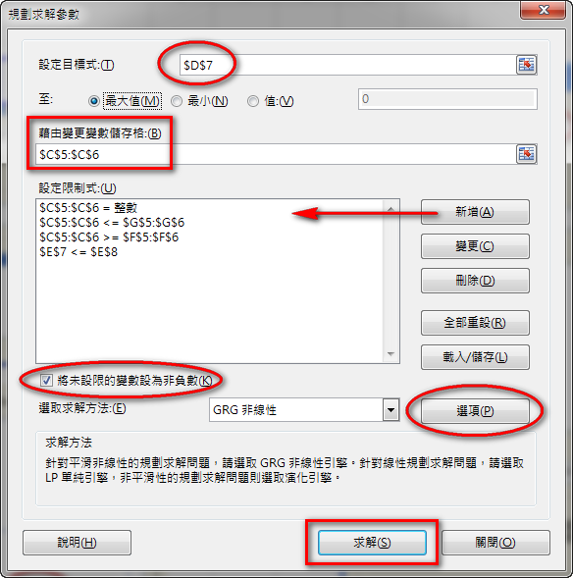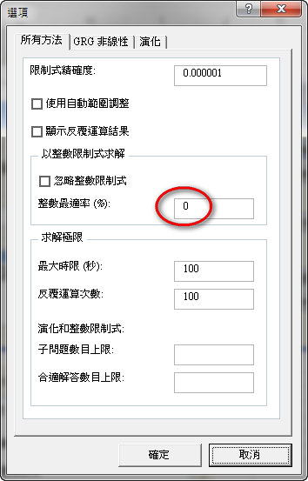
目標儲存格→D7 (最大值)
變數儲存格→C5:C6
限制式:
C5:C6 = integer
C5:C6 <= G5:G6
C5:C6 >= F5:F6
E7 <= E8
選項: 誤差 0%

Q1
某團體利用飛機把衣服、藥物送到地震災區。
(1) 衣服放箱、藥物放盒
(2) 每個箱和盒皆佔0.9立方米
(3) 一箱衣服重27kg、一盒藥物重54kg
飛機可載重21,600 kg, 容量540立方米
一箱衣服可幫助12家庭、一盒藥物可幫助18家庭
求最多可幫助多少個家庭

Q2
售價: 單層巴士$20; 雙層巴士$45
用最多$400買不多於10輛巴士
求各買巴士多少? 最多支出多少?

Q3
游泳池可容納最多250成人及250小童，且不可多於450人。
入場費: 成人$20、小童$15。每兩個小童必須有一個成人陪同。
求入場費的最大值。
Q4
(1) 造1kg蛋糕: 成本$60;
造1kg餅乾: 成本$30
製餅師傅最多花$1,200
(2) 製成的蛋糕、餅乾不可超過30kg
(3) 利潤為: 蛋糕$15/kg、餅乾$7/kg
(4) 最少要造5kg蛋糕及5kg餅乾
求最大利潤。

Q5
把350個蘋果放進x個盒及y個籃內。
一個盒可放25個蘋果、而一個籃可放10個蘋果。
盒的數目不可多於籃的數目
成本: 盒$12; 籃$6
求x和y (最低成本多少?)
Answers:
Q1. 400 200
Q2. 2 8
Q3. 250 200
Q4. 17 6
Q5. 10 10
Q6. 0.5 1.5
Q7. 10 10
Q8. 3 2
Q9. 15 45
Q10. 300 150
Q11. 7.5 5
Q12. 30 120

Q6
醫院為每個病人提供的食物須符合以下要求:
碳水化合物: | 至少120單位
蛋白質: | 至少40單位
纖維: | 至少30單位

食物 | 碳水化合物 | 蛋白質 | 纖維 | 成本 $/kg
P | 120 units | 20 units | 10 units | $60
Q | 40 units | 20 units | 30 units | $30
求最低成本多少?

Q7
生產商每天生產x個雪櫃及y座電視。
(1) 8<=x<=14
(2) 5<=y<=10
(3) x+y不超過20
利潤為: 雪櫃$1600及電視$2400，求最大利潤

Q8
產品A,B,C是由成份M和成份N製成
(1) 每噸M可造: 4000件A, 20000件B, 6000件C
(2) 每噸N可造: 6000件A, 5000件B, 3000件C
工廠接獲訂單: 24,000件A, 60,000件B, 24,000件C
成本: M(每噸$4,000); N(每噸$3,000)
要完成訂單，最低成本多少?

Q9
農夫想租田種生果及稻米。
租金: 生果田(每平方米$300)及稻米田(每平方米$100)
地主要求: 每租一平方米生果田，必須至少租三平方米稻米田
利潤: 種生果$600/平方米; 種稻米$150/平方米
若租金不超過$9000，求最大利潤

Q10
超級市場售賣橙汁及蘋果汁。
超級市場經理訂了橙汁的數量，至少是蘋果汁數量的兩倍。
超級市場只可容納450瓶果汁
利潤: 橙汁$2.5; 蘋果汁$3.0
求最大利潤

Q11
機器A: 每小時可生產120 nuts及100 bolts
運作成本: 每小時$150
機器B: 每小時可生產 60 nuts及150 bolts
運作成本: 每小時$180
若要完成至少1200 nuts及1500 bolts
機器A及B各需要運作多少小時? 最低成本多少?

Q12
計劃中的新酒店有單人房及雙人房若干。
(1) 每4間雙人房，必須有1間單人房
(2) 房間總數最多200間
(3) 單人房至少20間；雙人房最多120間
每日租金: 單人房$800；雙人房$1000
求單人房及雙人房各佔多少間，每日最多可收取租金多少?

1. 打開 Y:\F4-ICT\Class-List.xlsx 工作表：school
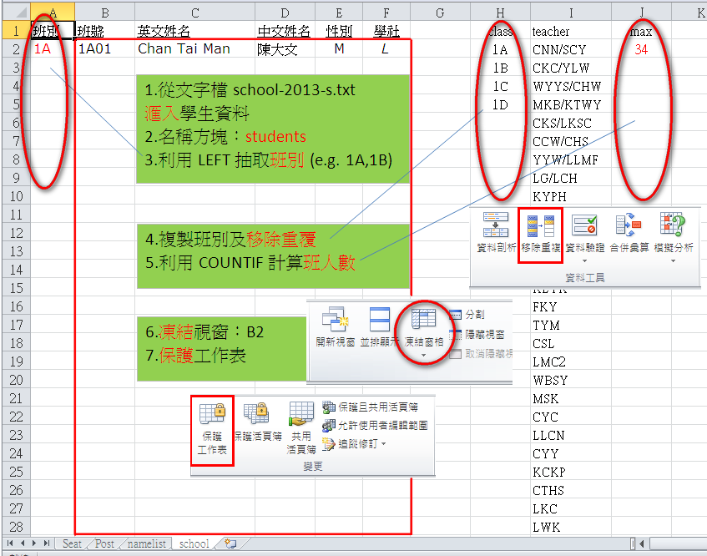
school-2016.txt
2. 文字檔 Y:\F4-ICT\school2016.txt
班號 英文姓名 中文姓名 性別 學社
1A01 Chan Tai Man 陳大文 M S
1A02 Chan Siu Ming 陳小明 M L
...
3. 工作表：namelist 建立學生名單
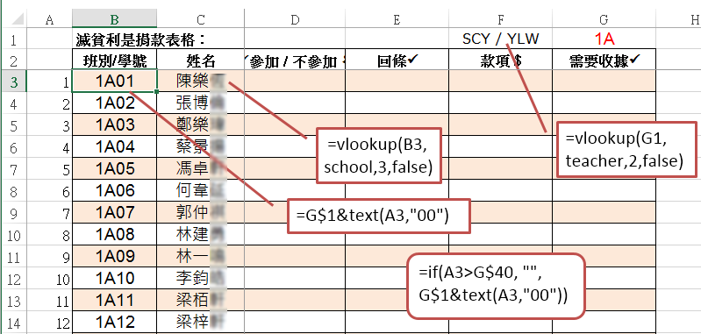
該班人數G40: =vlookup(…) 例如： 32 人

=vlookup(B3,school,3,false)
=if(A3>G$40, "",G$1&text(A3,"00"))
=vlookup(G1,teacher,2,false)

4. 工作表：namelist (自動格式化B2:G39)
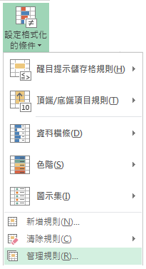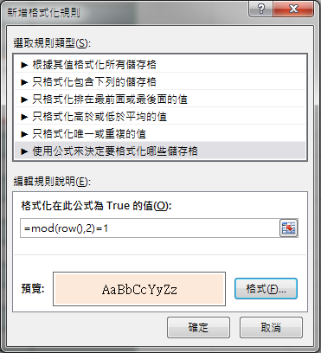
常用
=row() 顯示行號 =mod(10,2) 計算10%2

資料移除重複(班別1A,1B,…)
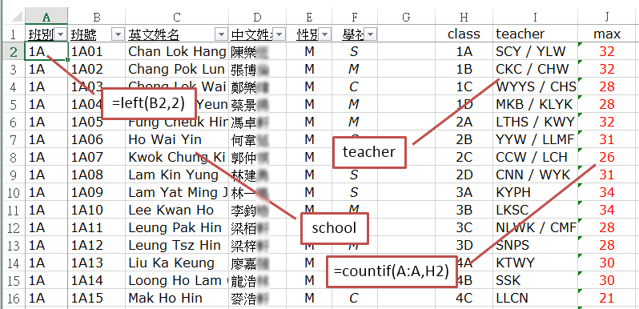
範圍：school (B2:F756) 範圍：teacher (H2:J28)

G1、資料、驗證、清單 (1A,1B,1C,1D,…,6E)
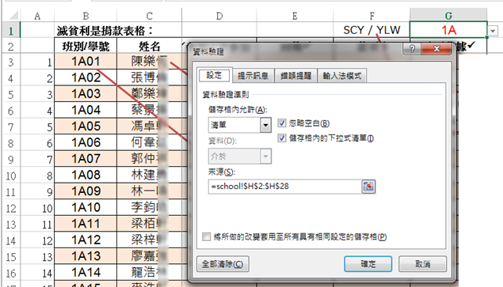
資料來源：=school!$H$2:$H$28

午膳訂購：school(raw_data!A2:W730)
RegNo | 班別 | 學號 | 姓名 | 5 | 6 | 7 | 8 | 9 | 12 | 13 | 14 | 15 | 19 | 20 | 21 | 22 | 23 | 26 | 27 | 28 | 29 | 30
161002 | 1A | 1 | 陳政 | A | A | X | X | C | A | C | X | X | A | B | X | X | A | D | A | X | X | B
161016 | 1A | 2 | 鄭祺 | A | D | B | D | B | A | A | B | A | A | B | A | B | B | D | B | B | B | A
161018 | 1A | 3 | 張天 | A | A | A | B | B | A | B | C | A | C | B | B | B | B | C | A | A | A | B
161022 | 1A | 4 | 蔡樂 | A | B | B | C | A | D | C | B | A | B | B | D | C | B | X | B | X | X | D
161028 | 1A | 5 | 徐安 | A | A | B | C | B | A | C | B | A | B | C | B | A | B | A | B | B | C | A
161030 | 1A | 6 | 鍾丞 | A | B | D | B | A | C | A | C | A | A | B | B | B | B | A | B | C | A | A
161032 | 1A | 7 | 樊彥 | A | B | B | C | A | B | C | C | A | D | D | B | B | B | A | B | A | C | B
161035 | 1A | 8 | 符泓 | A | A | X | X | A | A | C | D | X | A | X | C | A | D | C | A | X | A | C
161038 | 1A | 9 | 何曉 | A | B | C | B | A | B | A | C | B | Ag2 | B | C | B | A | B | A | C | A | B
=MATCH(DAY(TODAY()),raw_data!A1:AB1,0)
 | A | B | C | D | E | F | G | H
 | RegNo | Count | Class | No | Name | Meal | 6/10/2016 | 6
1 | 161001 | 2 | 1A | 23 | 包懿 | A | =today()
2 | 161002 | 1 | 1A | 1 | 陳政 | A
3 | 161001 | 2 | 1A | 23 | 包懿 | A
4 | 131119 | 1 | 4A | 29 | 楊芷 | B
5 | 131033 | 1 | 4B | 19 | 鍾嘉 | B
6 | 131059 | 1 | 4B | 23 | 林思 | B
=COUNTIF(A:A,A2) =VLOOKUP($A2,school,4,FALSE)

String Q1 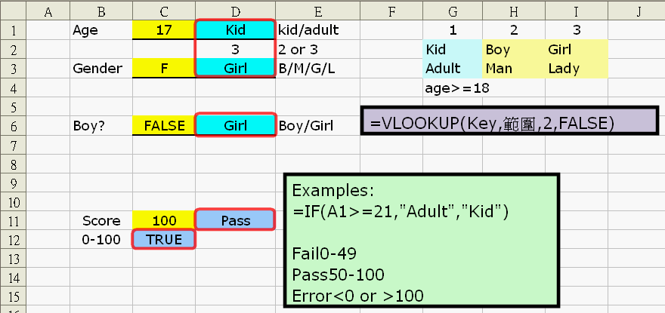
Q2 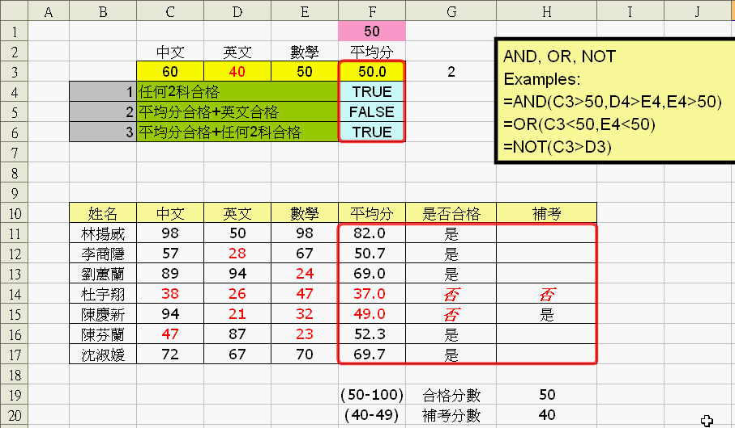
Q3.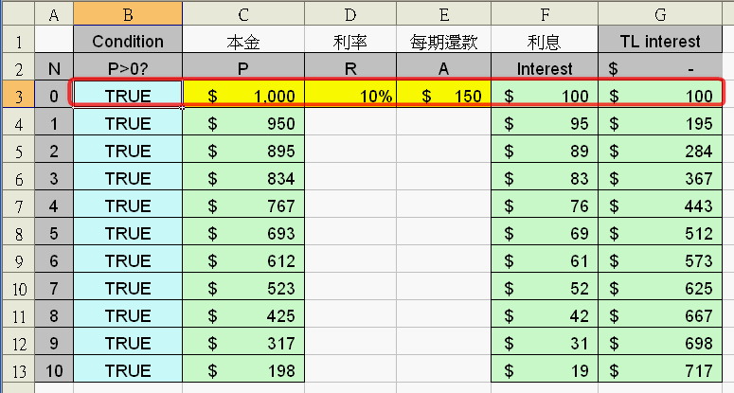

Q4
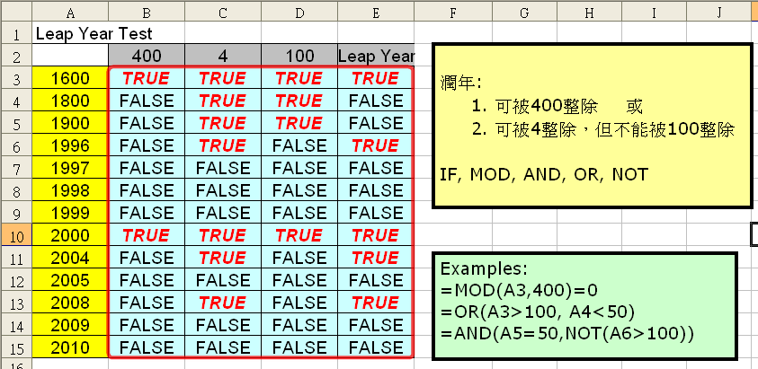
Q5
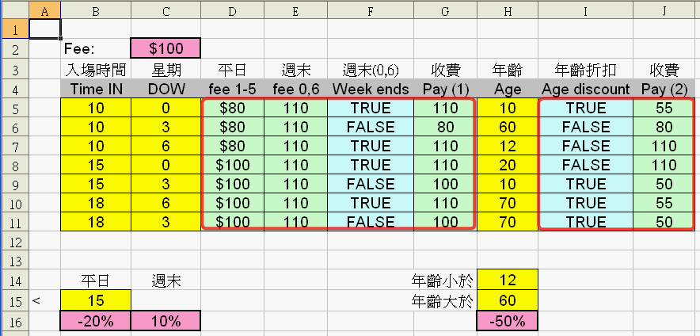
Q6
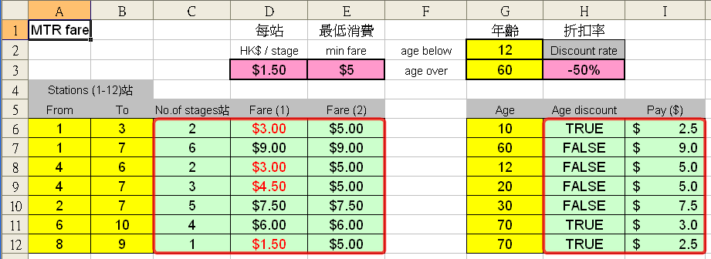

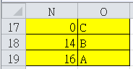
Q1 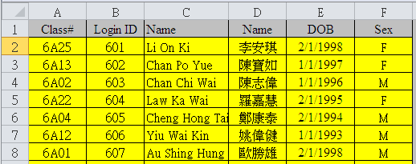
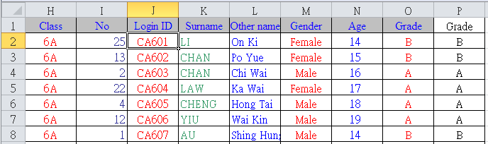
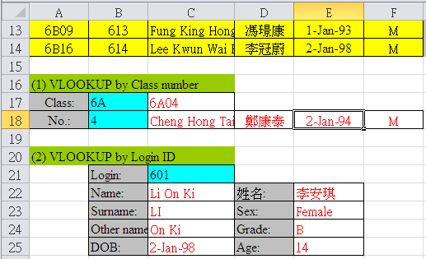
Q2 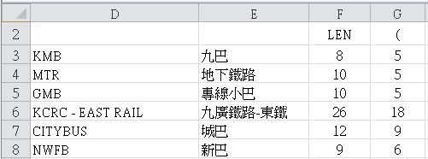

Q3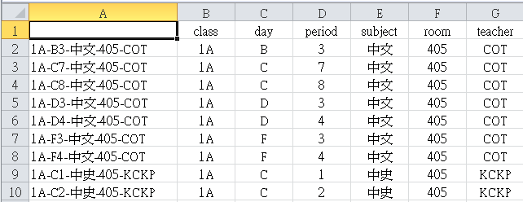
Q4
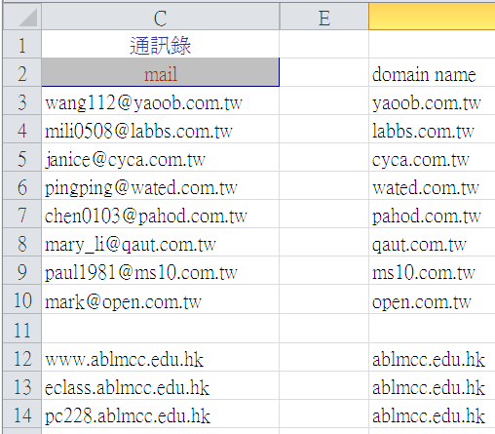
Q5
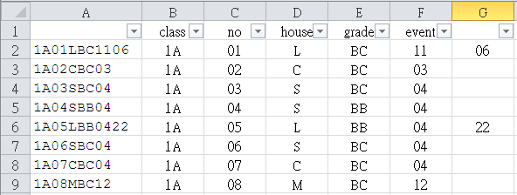
Q6 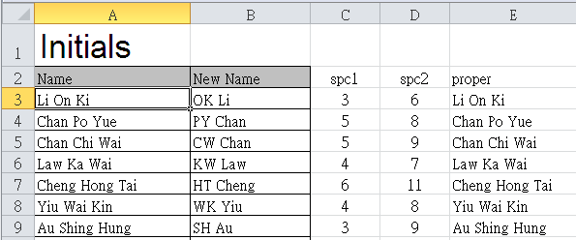
Q7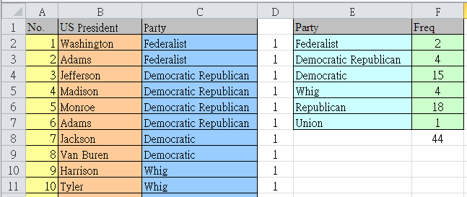
Q8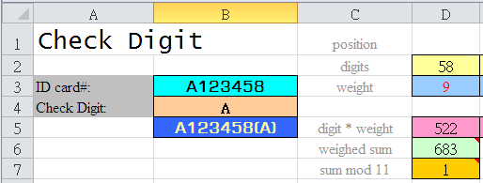
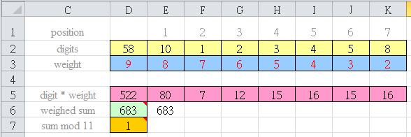
Q9 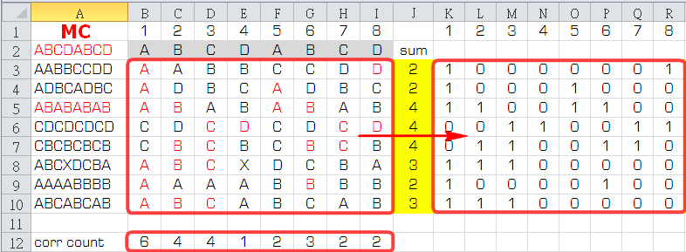
Q10
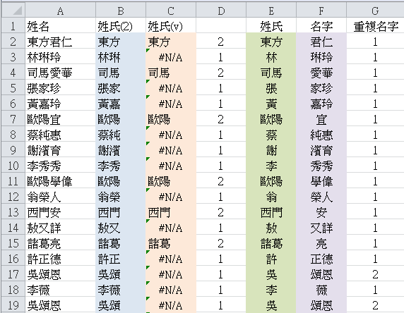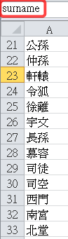
Q11a 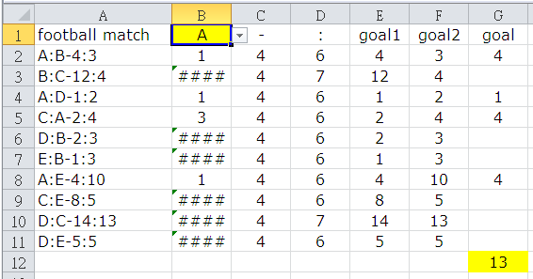
Q11b 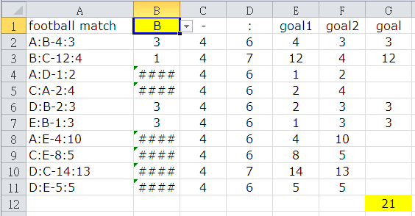
Q11c 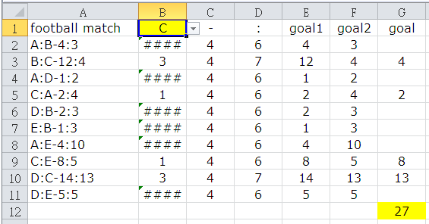
 | A | B | C | D | E | F | G | H | I
1 | 班別 | 班號 | 姓名 | 性別 | 學社 |  | L
2 | 1A | 1A01 | 陳元 | M | L |  | 2 | =small(G$2:G$730,1) | 1A01
3 | 1A | 1A02 | 鄭祺 | M | M |  |  | =small(G$2:G$730,2) | 1A05
4 | 1A | 1A03 | 張賜 | M | C |  |  | =small(G$2:G$730,3) | 1A07
5 | 1A | 1A04 | 蔡樂 | M | C |  |  |  | :
6 | 1A | 1A05 | 徐安 | M | L |  | 6
7 | 1A | 1A06 | 鍾謙 | M | S
8 | 1A | 1A07 | 樊廷 | M | L |  | 8
9 | 1A | 1A08 | 符曜 | M | S
[G2] =IF(E2=G$1,row(),"")
[I2] =INDEX(B:B,H2)
[H2] =small(G$2:G$730,row()-1)

Data Table 運算列表
1
本金 | principal | 1000000 | =PMT(r%/12,120期,1000000)
利率 | interest rate | 6%
年期 | years | 10
期數 | months | 120
每月供款 | repayment | -$11,102 | 5% | 6% | 7% | 8%
 |  | 2 | -43871 | -44321 | -44773 | -45227
 |  | 4 | -23029 | -23485 | -23946 | -24413
 |  | 6 | -16105 | -16573 | -17049 | -17533
 |  | 8 | -12660 | -13141 | -13634 | -14137
 |  | 10 | -10607 | -11102 | -11611 | -12133
 |  | 12 | -9249 | -9759 | -10284 | -10825
 |  | 14 | -8289 | -8812 | -9354 | -9913
 |  | 16 | -7577 | -8114 | -8672 | -9249
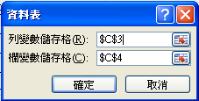
2
原價 price | $80  資料→模擬分析→運算列表
數量 quantity | 10
折扣 discount | 10%

應付 Net Pay | 720 | $25 | 30 | 35 | 40 | 45 | 50
 | 5 | 112.5 | 135.0 | 157.5 | 180.0 | 202.5 | 225.0
 | 10 | 225.0 | 270.0 | 315.0 | 360.0 | 405.0 | 450.0
 | 15 | 337.5 | 405.0 | 472.5 | 540.0 | 607.5 | 675.0
 | 20 | 450.0 | 540.0 | 630.0 | 720.0 | 810.0 | 900.0
 | 25 | 562.5 | 675.0 | 787.5 | 900.0 | 1012.5 | 1125.0
 | 30 | 675.0 | 810.0 | 945.0 | 1080.0 | 1215.0 | 1350.0
 | 35 | 787.5 | 945.0 | 1102.5 | 1260.0 | 1417.5 | 1575.0
 | 40 | 900.0 | 1080.0 | 1260.0 | 1440.0 | 1620.0 | 1800.0
 | 45 | 1012.5 | 1215.0 | 1417.5 | 1620.0 | 1822.5 | 2025.0
 | 50 | 1125.0 | 1350.0 | 1575.0 | 1800.0 | 2025.0 | 2250.0

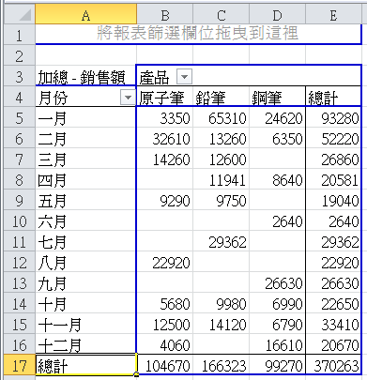
Pivot Table
插入→樞紐分析表
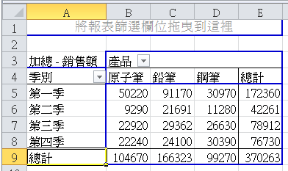

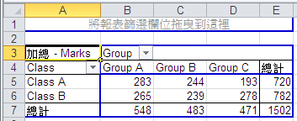
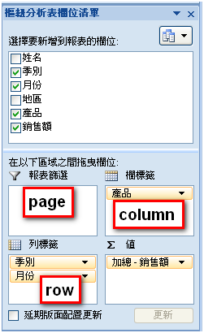
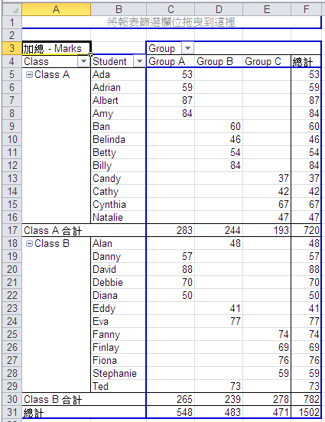

57
=INTERCEPT(y-values,x-values) | y-intercept (when x=0)
=INTERCEPT(A1:A5,B1:B5)
=INDIRECT(A1)
60 Custom Format: (自訂格式)
G/通用格式
0 | 0.00 | #,##0 | #,##0.00
_–* #,##0_–;–* #,##0_–;_–* "–"_–;_–@_–
_–* #,##0.00_–;–* #,##0.00_–;_–* "–"??_–;_–@_–
_–$* #,##0_–;–$* #,##0_–;_–$* "–"_–;_–@_–
_–$* #,##0.00_–;–$* #,##0.00_–;_–$* "–"??_–;_–@_–
#,##0;–#,##0 |  | $#,##0;–$#,##0
#,##0;[紅色]–#,##0 |  | $#,##0;[紅色]–$#,##0
#,##0.00;–#,##0.00 |  | $#,##0.00;–$#,##0.00
#,##0.00;[紅色]–#,##0.00 |  | $#,##0.00;–$#,##0.00
0% |  | ##0.0E+0
0.00% |  | # ?/?
0.00E+00 |  | # ??/??
"US$"#,##0_);("US$"#,##0) |  | "US$"#,##0_);[紅色]("US$"#,##0)
"US$"#,##0.00_);  ("US$"#,##0.00) |  | "US$"#,##0.00_);  [紅色]("US$"#,##0.00)
d–mmm |  | d–mmmm–yy
mmm–yy |  | m/d/yy
e"年"m"月"d"日" |  | e/m/d
yyyy"年"m"月"d"日" |  | yyyy/m/d
hh"時"mm"分" |  | hh:mm
hh"時"mm"分"ss"秒" |  | hh:mm:ss
上午/下午hh"時"mm"分" |  | hh:mm AM/PM
上午/下午hh"時"mm"分"ss"秒" |  | hh:mm:ss AM/PM
 |  | yyyy/m/d hh:mm
mm:ss |  | @
mm:ss.0 |  | [h]:mm:ss
61 自定清單Auto Fill
Horoscope? Aquarius, Pisces, Aries, Taurus, Gemini, Cancer,
Leo, Virgo, Libra, Scorpio, Sagittarius, Capricorn
星座 ? 水瓶,雙魚,白羊,金牛,雙子,巨蟹,獅子,處女,天秤,天蠍,人馬,山羊座
十二生肖 ? 猴,雞,狗,豬,鼠,牛,虎,兔,龍,蛇,馬,羊
顏色 ? 紅,橙,黃,綠,青,藍,紫
one, two, three, four, five, six, seven, eight, nine, ten,
eleven, twelve, thirteen, fourteen, fifteen, sixteen, seventeen, eighteen, nineteen,twenty, thirty, forty, fifty, sixty, seventy, eighty, ninety
一二三四五六七八九十I, II, III, IV, V, VI, VII VIII, XI, X, ..., L, D, M

1. 打開 Y:\F4-ICT\Seating-Plan-F4.xlsx 工作表：school
2. 文字檔 Y:\F4-ICT\school-s.txt
班號#英文姓名#中文姓名#性別#學社
1A01#Cheng Chun Ho#鄭駿浩#M#M
1A02#Choy Chung Yin#蔡仲賢#M#L
...

3. 工作表：namelist
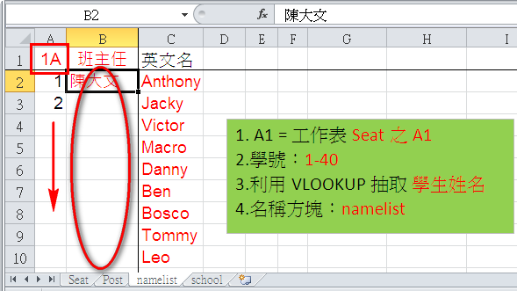
4. 工作表：seat
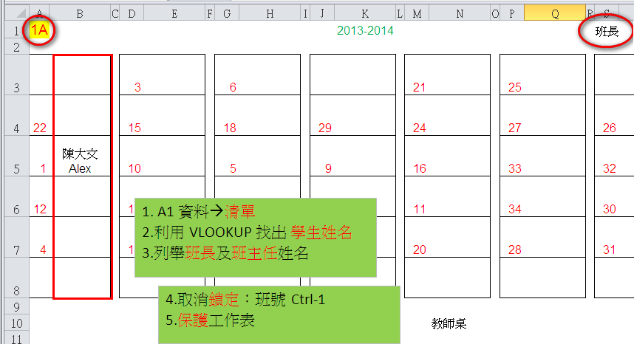
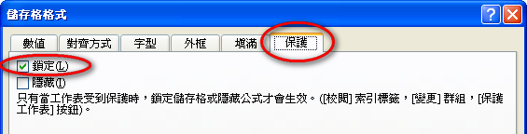

5. 額外練習：利用MS Word把文字檔內#號轉為 ____ (tab)，再於Excel貼上。

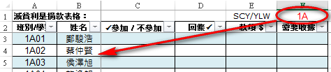
6. 額外練習：製作班分紙class-list.xlsx。

重溫： =VLOOKUP(_____, ______, ______, FALSE)

=IF(A1____, "Fail", "Pass")

保留字
數據庫（SQL指令 ── 建基於SQL-92 標準）
常數 | TRUE, FALSE
運算符 | +, -, *, /, >, <, =, >=, <=, <>, %, _ , ' , AND, NOT, OR
SQL | ABSOLUTE (ABS), AVG, INT, MAX, MIN, SUM, COUNT, AT, CHAR_LENGTH (LEN), LOWER, TRIM, SPACE, SUBSTRING (SUBSTR/MID), UPPER, AS, BETWEEN, BY, ASC, DESC, DISTINCT, FROM, GROUP, HAVING, LIKE, NULL, ORDER, SELECT, WHERE

電子試算表
常數 | TRUE, FALSE
運算符 | +, -, *, /, <, >, =, <>, <=, >=
函數 | ABS, INT, RAND, SQRT, ROUND, AND, NOT, OR, CHAR, CONCATENATE (&), ISBLANK, LEFT, LEN, LOWER, MID, PROPER, RIGHT, TEXT, TRIM, UPPER, VALUE, AVERAGE, COUNT, COUNTA, COUNTBLANK, COUNTIF, MAX, MIN, RANK, SUM, SUMIF, FIND, VLOOKUP, IF

